**Training The Model In Multiple Algorithms**

Now our data is cleaned and it’s time to build the model. We can train our data on different algorithms. For this project we are applying three classification algorithms. The best model is saved based on its performance.

**Random forest model**

A function named randomForest is created and train and test data are passed as the parameters. Inside the function, the RandomForestClassifier algorithm is initialized and training data is passed to the model with the .fit() function. Test data is predicted with .predict() function and saved in a new variable. For evaluating the model, a confusion matrix and classification report is done.

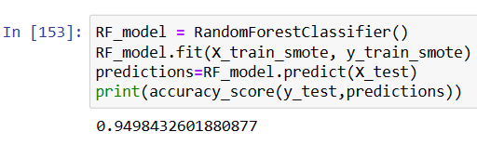

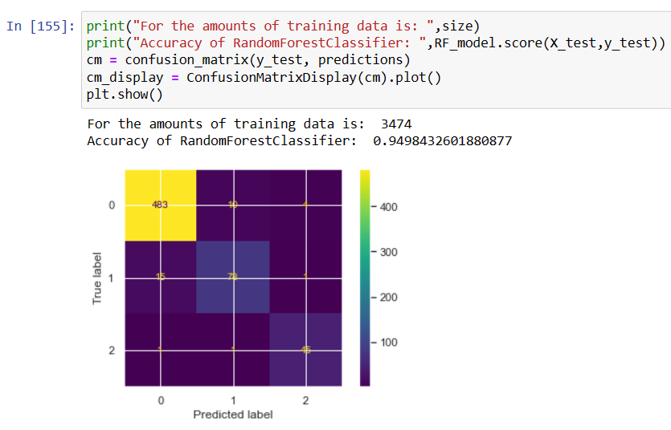

**Decision Tree**

A function named decisionTree is created and train and test data are passed as the parameters. Inside the function, DecisionTreeClassifier algorithm is initialized and training data is passed to the model with the .fit() function. Test data is predicted with .predict() function and saved in a new variable. For evaluating the model, a confusion matrix and classification report is done.

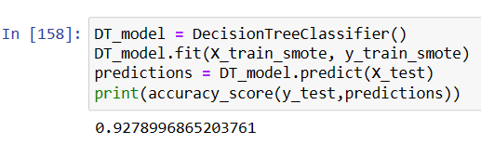

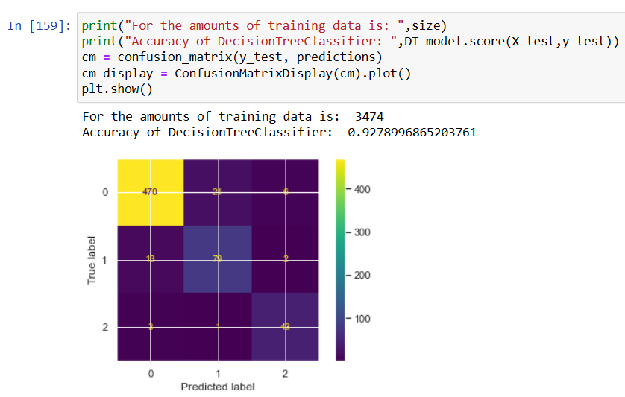

**Logistic Regression**

A function named LogisticRegression() is created and train and test data are passed as the parameters. Inside the function, LogisticRegression algorithm is initialized and training data is passed to the model with the .fit() function. Test data is predicted with .predict() function and saved in a new variable. For evaluating the model, a confusion matrix and classification report is done.

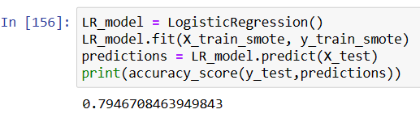

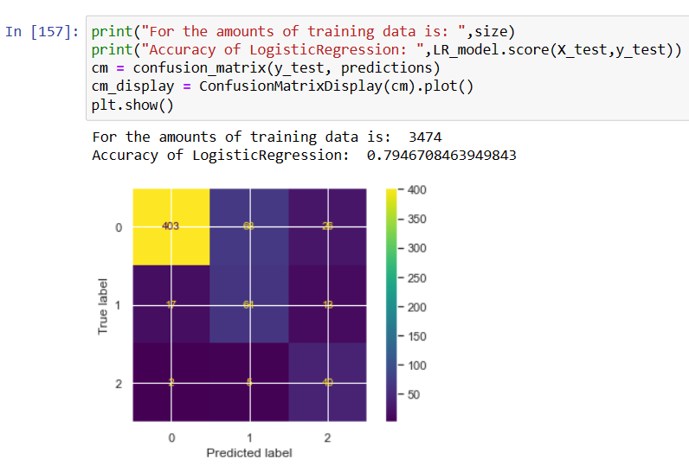

**K-Nearest Neighbors**

A function named KNeighborsClassifier() is created and train and test data are passed as the parameters. Inside the function, KNeighbors algorithm is initialized and training data is passed to the model with the .fit() function. Test data is predicted with .predict() function and saved in a new variable. For evaluating the model, a confusion matrix and classification report is done.

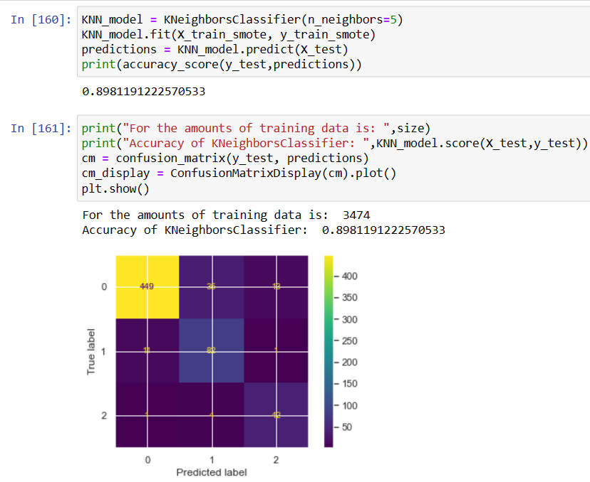

**Testing The Model**

